**Soil Lab Data Mart Modernized: Soil Data at Your Fingertips**

**[city], [state] – [month] [day], [year] –** The USDA Natural Resources Conservation Service (NRCS) announces the release of an updated National Cooperative Soil Survey (NCSS) Lab Data mart website. This website, also known as the “[National Cooperative Soil Survey (NCSS) Soil Characterization](https://ncsslabdatamart.sc.egov.usda.gov/)” Data delivers laboratory results of soil samples analyzed by the [National Soil Survey Center](http://www.nrcs.usda.gov/wps/portal/nrcs/detail/national/contact/centers/nssc/?cid=nrcs142p2_053895).

Quick facts:

* The website of the Kellogg Soil Survey Laboratory (KSSL) and the National Cooperative Soil Survey (NCSS) has been modernized. It is now more intuitive, making it easier to navigate and find information.
* The historical method for querying lab data is still available.
* A new process has been implemented for updating the lab data on a more regular basis.
* Open-source databases and companion morphological data are now available. Nearly all the KSSL data and associated pedon data are available for download. You can download in several different database formats: SQLite, Access, GeoPackage and ESRI File Geodatabase.
* The update uses a new, simplified, database model schema.
* New data tables and columns are available.
* Interactive metadata documentation is available for the new tables.
* The previous web map has been replaced with an open-source, leaflet map that uses automated data.
* The map now allows you to select custom areas and to download the data in a database format of your choice.
* For the benefit of developers and data scientists, the lab tables are also available through the Soil Data Access (SDA) application and SDA web services. Custom SQL queries can be used to receive instant or e-mailed tabular results in xml, html, or text format. A suite of SDA web services is available to meet a variety of customer needs. The pedon data associated with the NCSS characterization data are not available through SDA.
* The Mid-infrared (MIR) spectroscopy data displayed on the map are available for download.

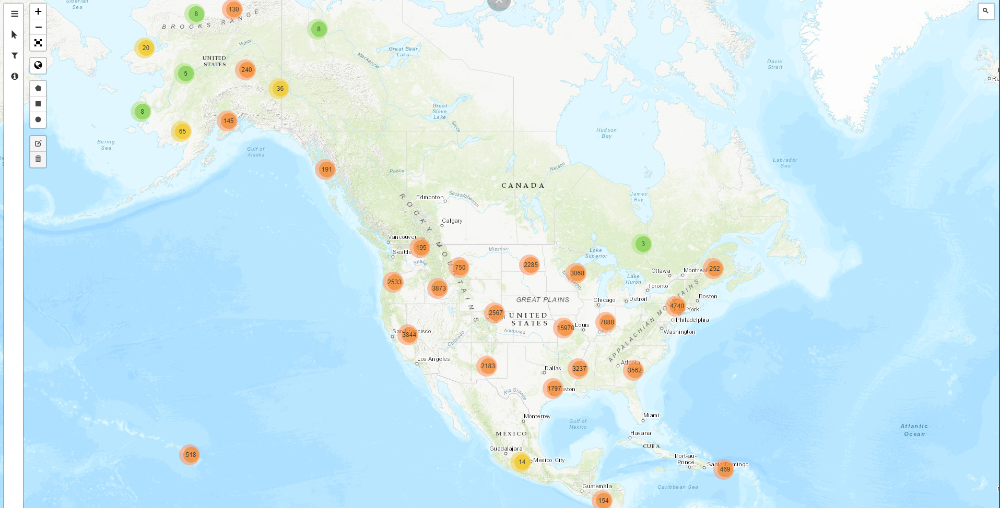Figure 1. —The interactive map showing updated sampled data, geochemical data and mid infrared sites.

The map links to a national database of soil characterization data and allows you to locate soil samples and “pedons” that have been analyzed in the lab. A pedon is the smallest unit of soil containing all the soil horizons of a particular soil type. Laboratory data is available for over 60,000 pedons and is the result of nearly 60 years of fieldwork and laboratory analysis by the National Cooperative Soil Survey. Historically, such laboratory information was aggregated into a soil survey report and only seen by a relatively few people, mostly scientists. Now, these data is easily available to everyone. Farmers, ranchers, researchers, and conservationists everywhere can take advantage of this valuable resource to support conservation, soil health, climate-change research, climate adaptation and climate-smart agriculture.

The update includes one of the largest libraries of Mid-Infrared (MIR) spectral data in the world. Gathered by cutting-edge technology, this data will be used by climate-change scientists and researchers studying carbon sequestration, carbon credit programs and soil health.

The map shows the location of individual pedons. Clicking on the map enables you to access lab data about a pedon. Additional information about soil laboratory data is available from the [NCSS Soil Characterization Basic Query](https://ncsslabdatamart.sc.egov.usda.gov/) website.

“The updated website and map give people nationwide a means to view data that can be used by educators, scientists, farmers, landowners, schools, soil judging teams, the general public and more,” said [Name], State Conservationist in [state].

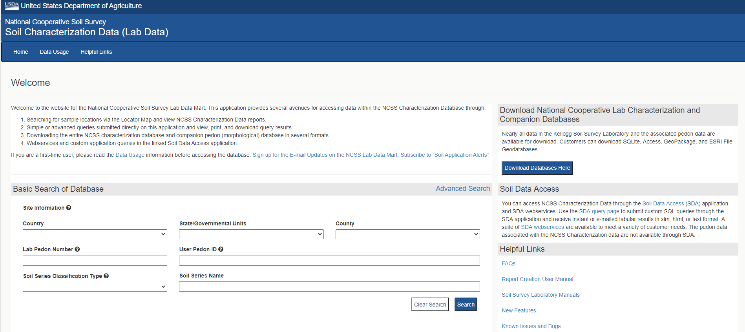

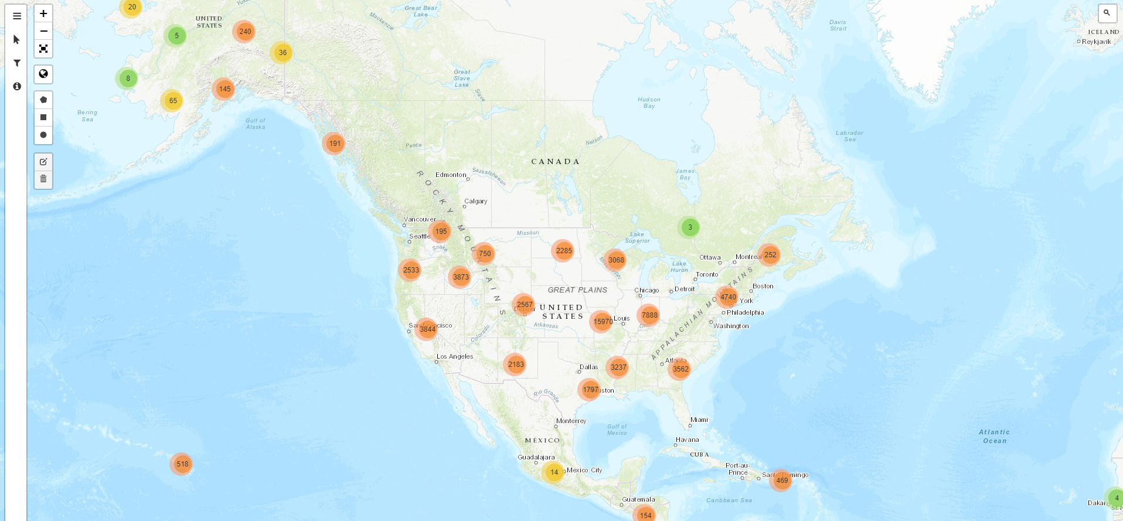

“The map lets you search for lab data by using filters or by exploring places you care about across the globe,” explained [First Name] [Last Name], State Soil Scientist in [State]. You can search by location and have soil data available at your fingertips.

The updated tool can assist scientists in developing conservation models that validate outcomes of conservation practices. You can pinpoint spots using location panels, full-screen maps and latitude and longitude. “Our new interactive map provides online access to our rapidly growing collection of lab data,” explained Skye Wills, National Leader for Soil Science Research.

Soil scientists, hydrogeologists, municipal water-utility operators, and water-quality regulators use lab data to understand the subsurface. The data viewer includes over 50,000 individual soil samples from across the world. Soil-sample data can also be viewed in reports.

The website lets you select different base maps; add maps of soil-color by depth; search by location, soil series or geographic location; download data to be used in other applications; search using filters and the search bar and stream from Soil Data Access web services. Popups for each pedon include several lab reports.